|  |  |
| --- | --- |
| Ex.No:2 | **DJANGO ORM** |
| Date: |

AIM:

To develop Django application to store and retrieve data from a Food Blog database using Object Relational Diagram(ORM).

**ALGORITHM:**

STEP 1: Create a django project with the name “myfoodblog”

STEP 2: Initiate a database & create data tables for existing models of the generated project in the database

STEP 3: Open a new windows client and move to the project workspace. Run the following command *to start up a local host.*

STEP 4: Creating a superuser and refresh http://127.0.0.1:8000/admin/ in your browser & sign in

STEP 5: Create an application in the *myfoodblog* project with the name “cuisine”

STEP 6: Define a cuisine model to handle posts by the owner / users of the blog , edit settings.py:

STEP 7: Add your cuisine model to the administration site. Customizing the way models (eg. Cuisine) are displayed in the admin app and customize the admin model some more.

**PROGRAM:**

**SETTINGS.PY**

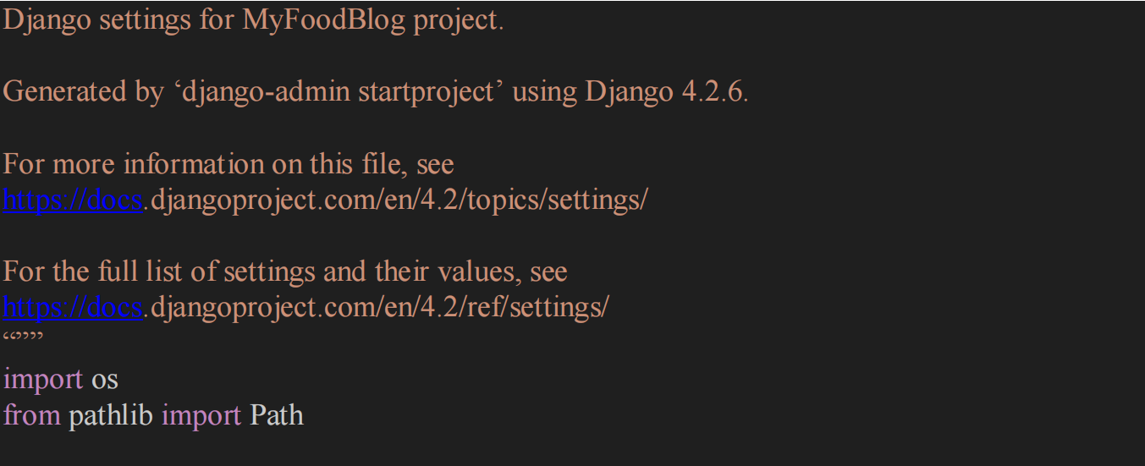

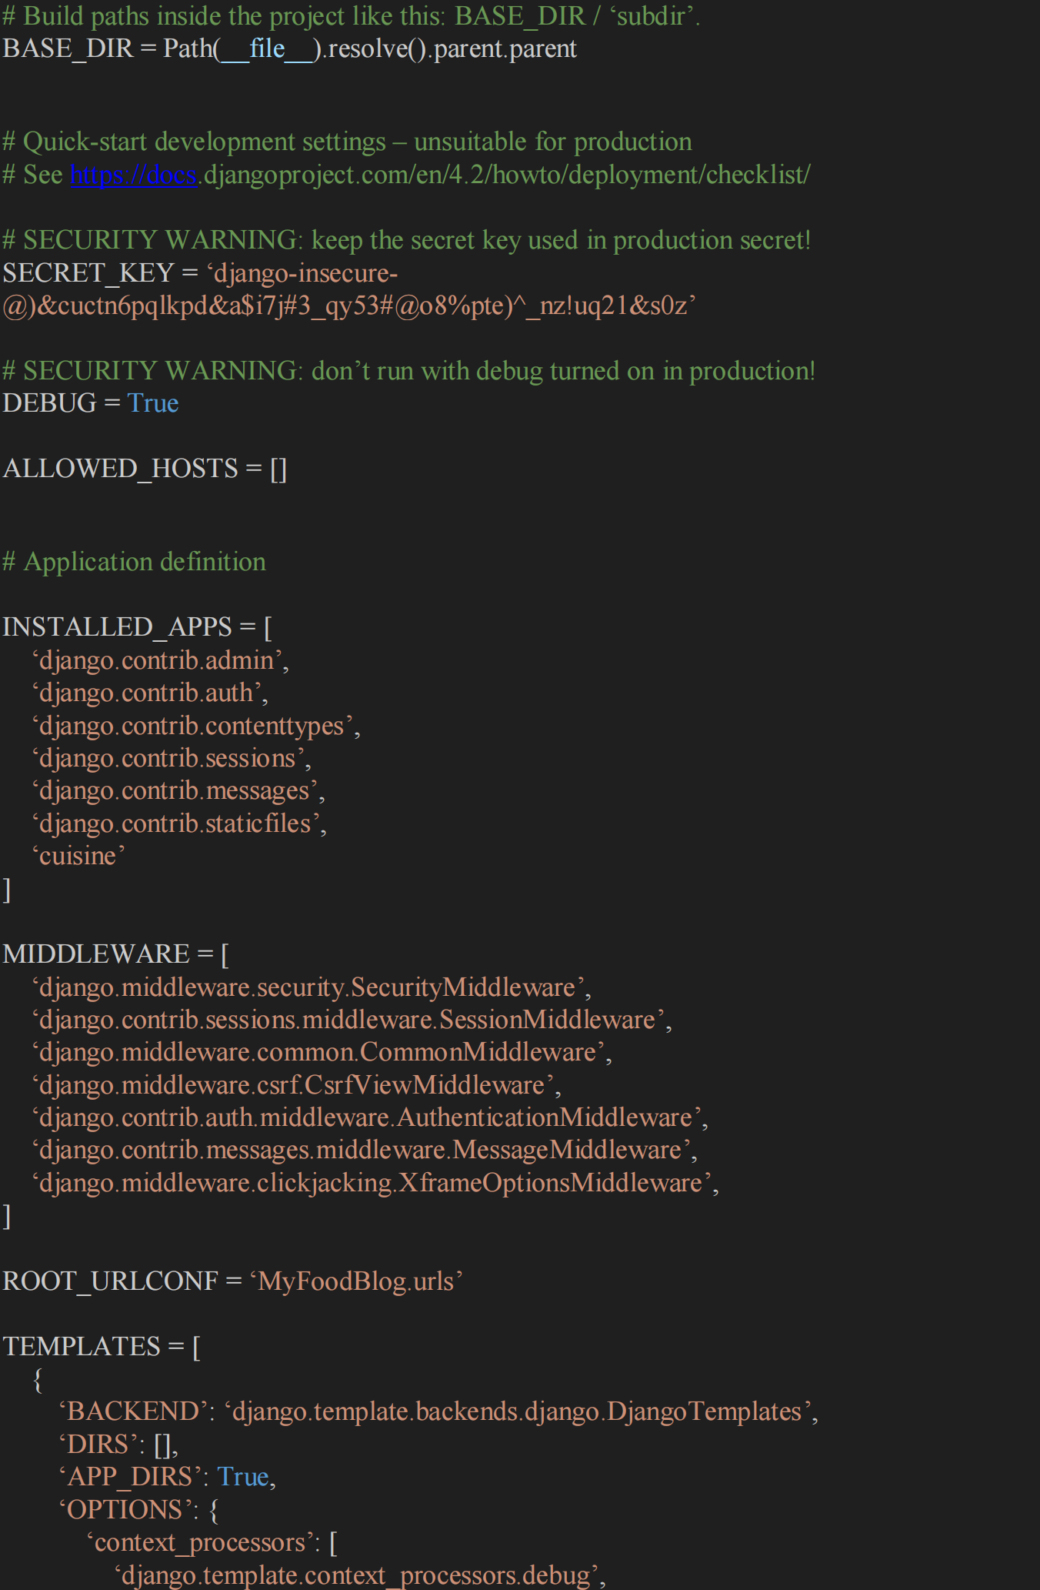

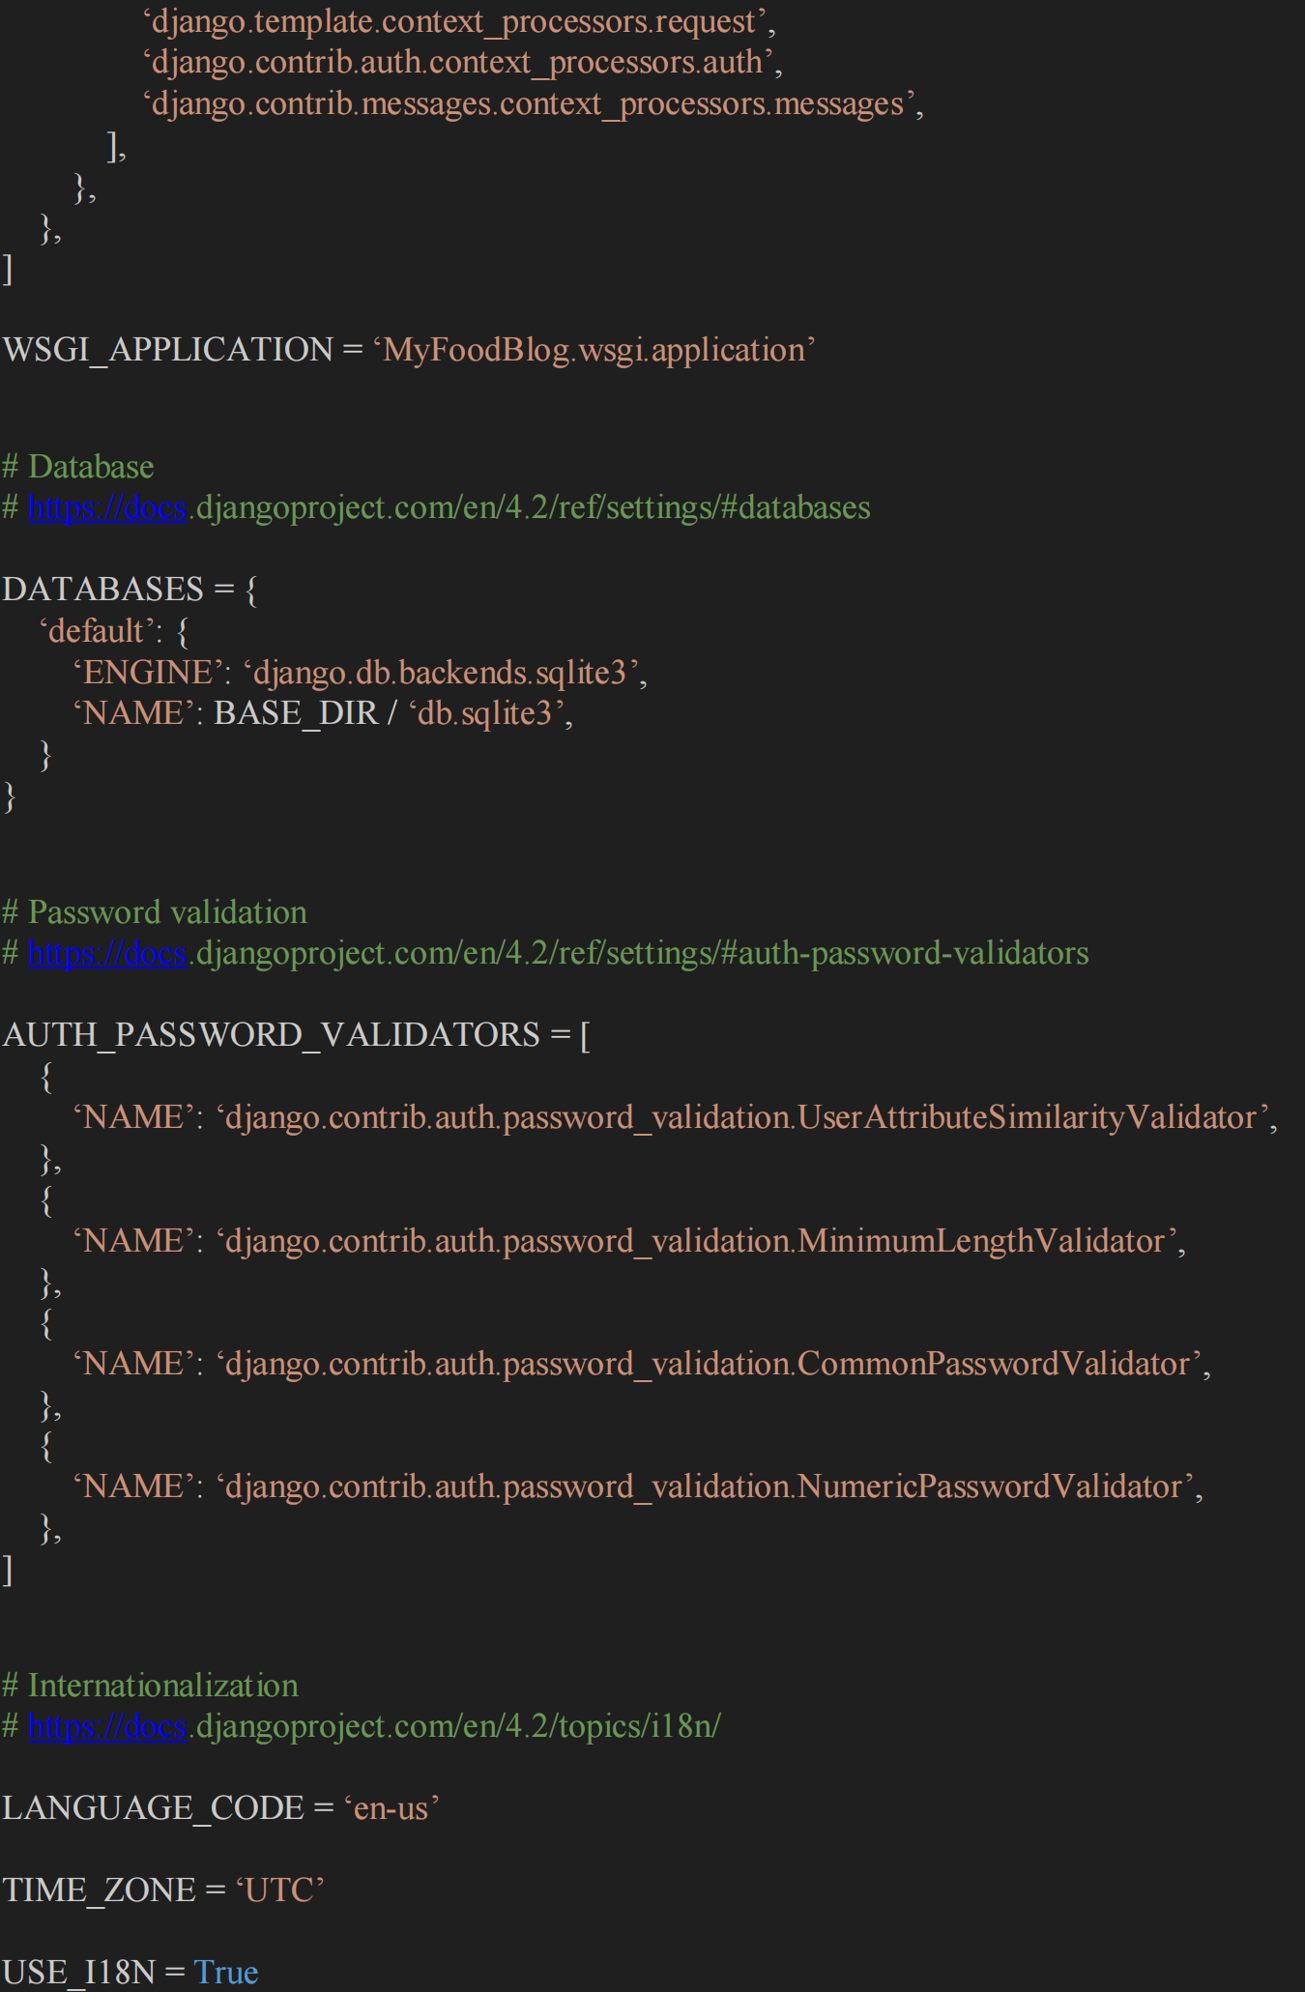

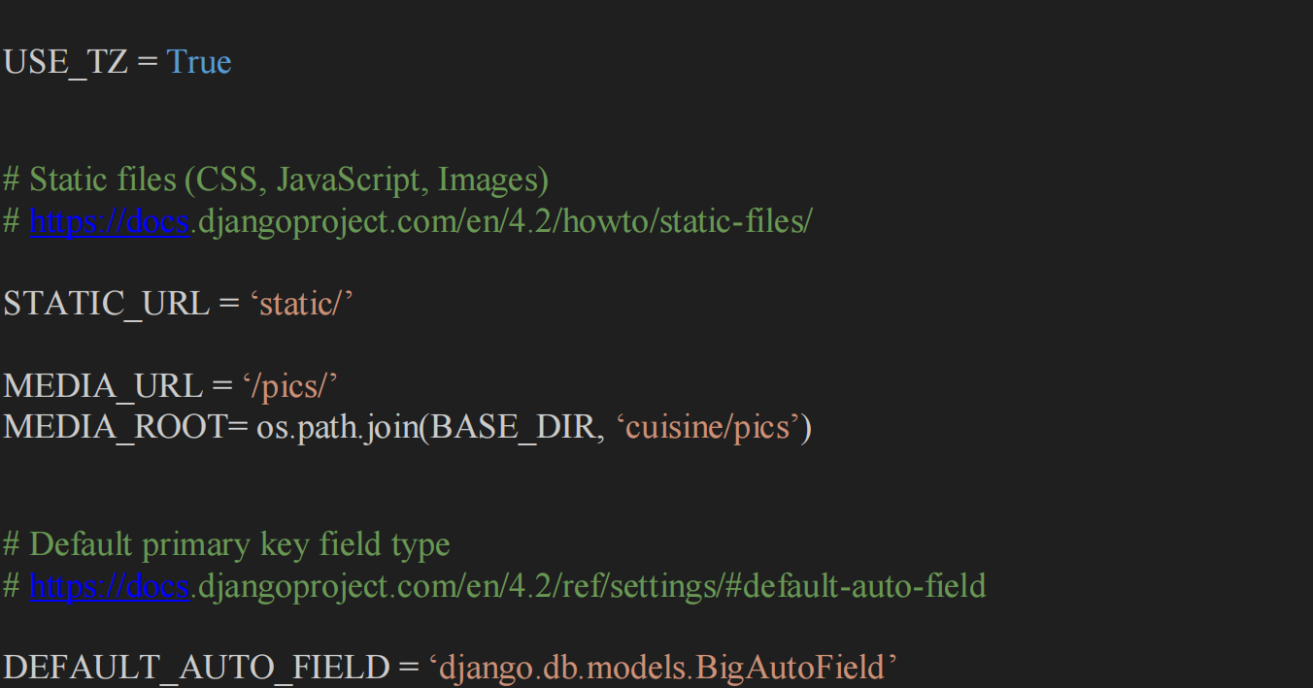

**MODEL.PY**

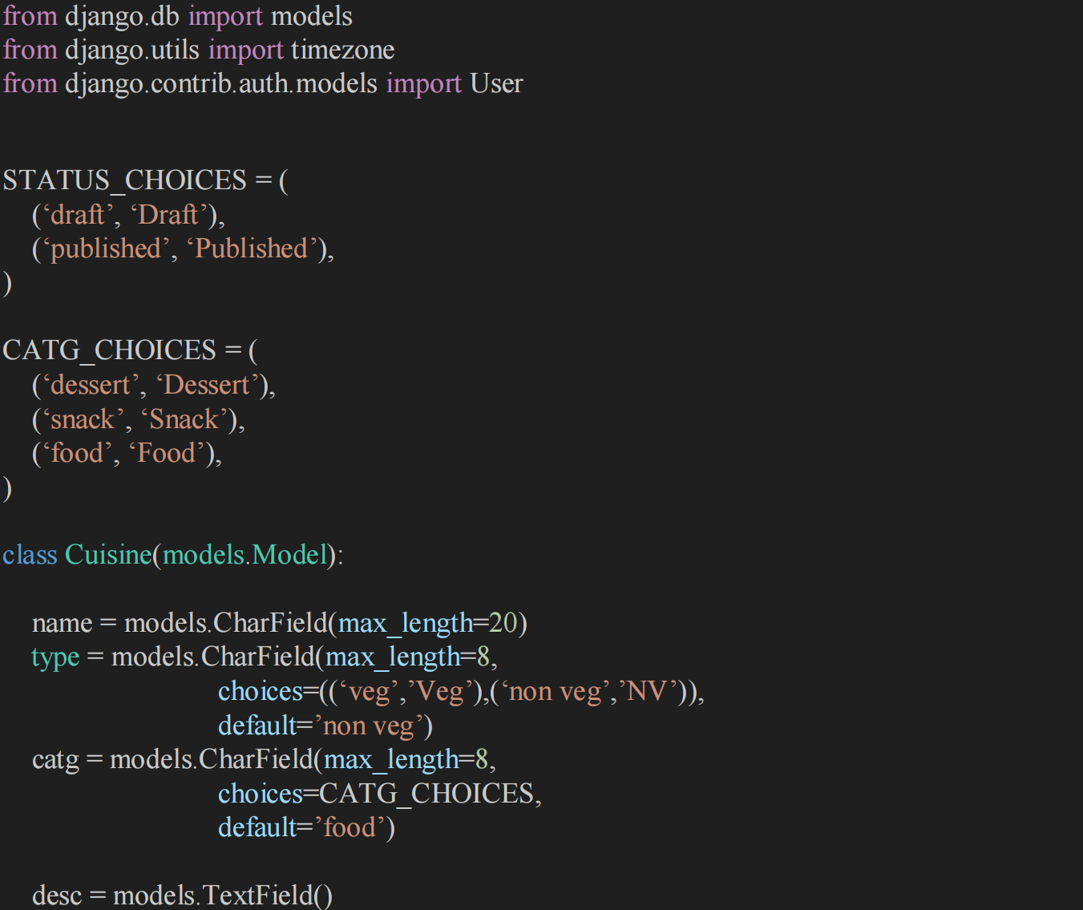

**OUTPUT:**

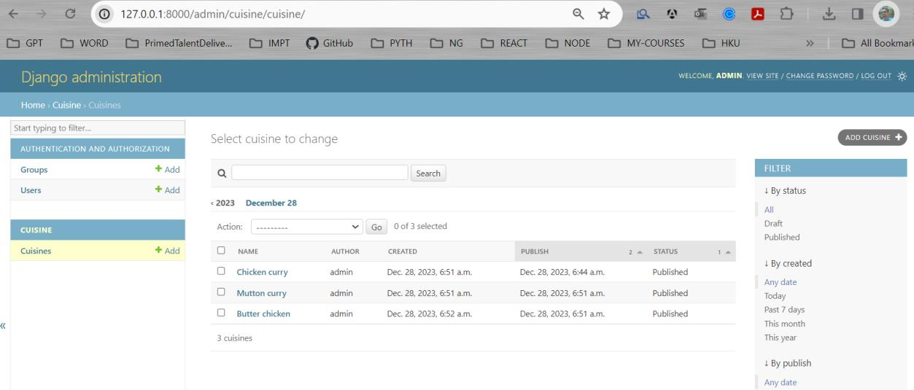

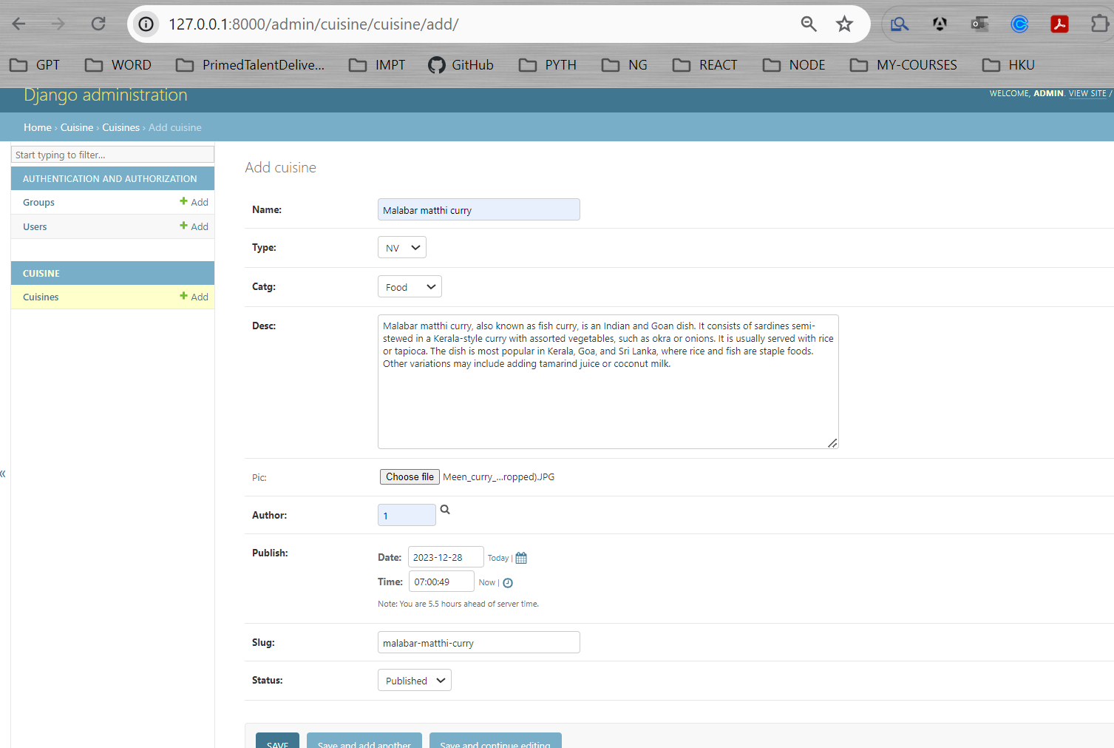

**RESULT:**

Thus the program for creating database using ORM has been created successfully.